Safety Training Program
Dave’s Stove Company builds commercial stoves and ovens for large appliance companies. It employs about 300 people, mostly assembly-line workers, and is located in a small rural town in North Carolina. This company typically builds, on a contract basis, designer stoves and ovens and heavy duty ovens and stoves. On occasion, however it builds smaller sized ovens and stoves. The President is a former engineer, as are most of the other executives. These individuals are very knowledgeable about engineering, but have received little training in the principles of management.
During the summer months, volume at the factory increases significantly and the company needs to hire about 40 new employees to handle the heavy workload. Most of these new employees are either college students who attend a small private college located about 15 minutes from the plant or retired people from the area. Some high school students are hired as well.
When a new employee is hired, the company asks him or her to complete an application and then show up at the plant gate ready for work. Employees receive no orientation. The worker shows up at a the work station and, after a minimum amount of on-the-job training, the new employee is expected to start performing a job. Most of the jobs are quite simple hence the training is typically completed in ten minutes. The first line supervisor usually shows the new employee how to do the job once, then watches as the employee does it once, and then comes back about 20 minutes later to see how they are doing. Typical jobs at the plant include screwing 14 screws at the side of the oven and stove, placing an inner panel inside, and handing out supplies from the tool room.
The company has had an excellent experience with this population over the years. Much of the success has been attributed to the experienced workers coming to the aid of the new employees when difficulty arises. Most new employees are able to perform their jobs reasonably well after their on the job training is completed. However when unexpected difficulties arise, they are usually not prepared for them and need assistance from others.
The older workers have been especially helpful to the students and retired people in the “press room”. However, Joe Gleason, the first line supervisor there, finds it amusing to belittle the college kids whenever they make mistakes. He relishes showing a student once how to bend metal, then exclaims, “You’re a hot shot college student; now let’s see you do it!” He then waits impatiently while the student invariably makes a mistake and then jokingly announces to the whole department, “That’s wrong! How did you ever get into college anyway? Try it again dummy!”
On summer, the company experienced a rash of injuries to its employees. Although most of the injuries were minor, the company felt it was imperative to conduct a series of short training programs on safe material-handling techniques. The president of the company realized that OSHA requires firms to maintain a safe and healthy work environment and that it is important that employees know how to lift properly and safely. The major issue was who should conduct the training. The human resource director was a64 year old former engineer who was about to retire and was a poor speaker. The only other employee in human resources was a new 19 year old secretary who knew nothing about proper handling techniques. Out of desperation, the president finally asked Bill Young, the first line supervisor from the “Lid Line” to conduct the training. Young had recently attended a training program himself on safety and active in the American Red Cross. He reluctantly agreed to do the training. It was done on a department basis with small groups of employees. 10 – 15 employees attended each session.
At the first of the training sessions, Young nervously stood up in front of 14 employees, many of whom were the new workers, and read his presentation in a monotone voice. The entire speech lasted about one minute and consisted of the following text:
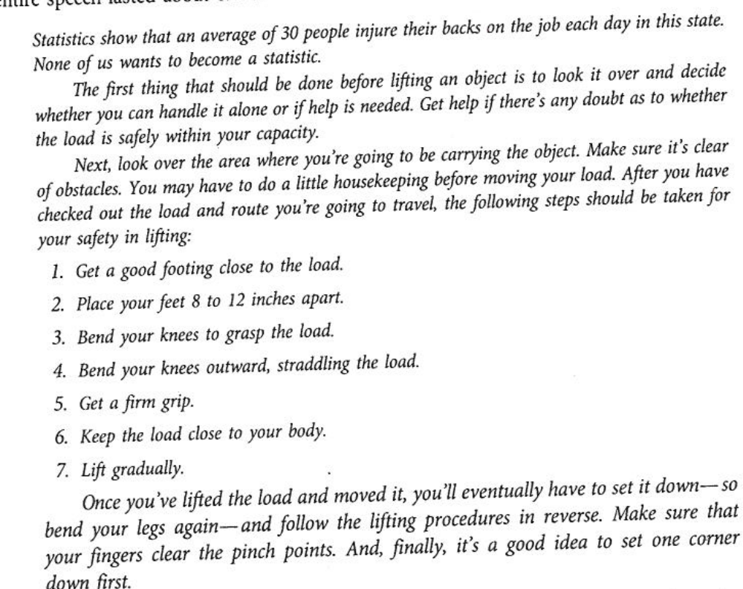

After Bill’s speech ended, the employees immediately returned to work. By the end of the day, however everyone in the plant had heard about the training fiasco, and all, except the president were laughing.
Adapted from case 52 in Human Resource Management Applications, Nkomo, 7th Edition, McGraw - Hill

